C’mon & JUMP UP!™ with

PATTY HALL 

Hey kids! And grownups too! Join
Author/Singer/ Songwriter PATTY HALL
at the
EMERYVILLE
BARNES & NOBLE
for her very special JUMPIN UP!™ SONGS & STORIES,
a books-and-music celebration for the whole family!

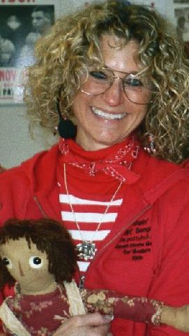

Patty will read aloud from her newest Pelican book,
THE
HONEST-TO-GOODNESS STORY OF RAGGEDY ANDY
and share some Raggedy history.

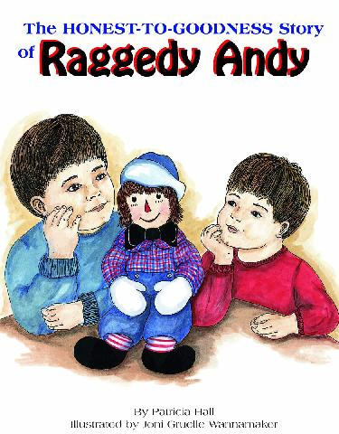

BARNES & NOBLE
5604 BAY STREET
EMERYVILLE, CALIFORNIA



WEDNESDAY
APRIL 6, 2005



11:00 AM



She’ll also perform some traditional and original JUMPIN’ UP!™ SONGS and you’ll get to sing along, dance, and even join in on special instruments Patty brings with her.

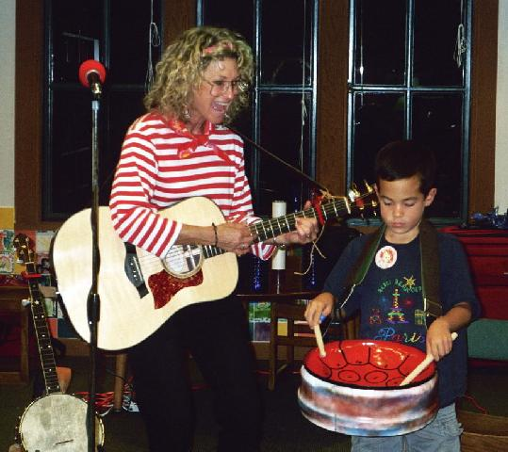

So, tune up your voices, grab YOUR favorite doll or bear, and come on down to BARNES & NOBLE to raise a JUMPIN’ UP!™ ruckus in honor of the Raggedys!


A book signing will follow the program.


For more info call
510-547-0905
or visit
www.pattyhall.com

