MEET JONI & PATTY!

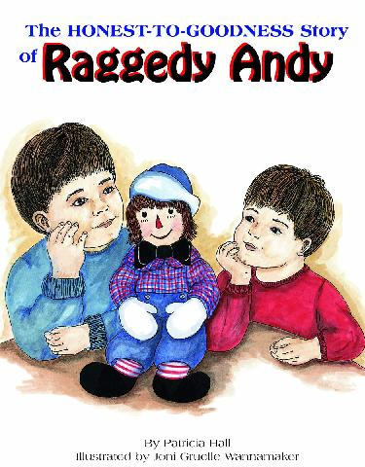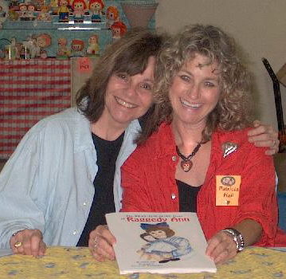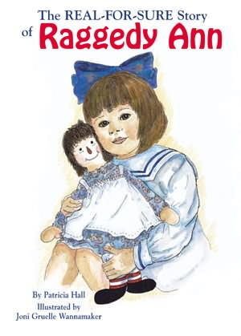

Want to hear an Honest-to-Goodness new story, learn how to draw a Real-for-Sure Raggedy, and sing along on a Jumpin’ Up!™ song or two?
Then come on along and join the fun with
PATTY HALL and JONI GRUELLE WANNAMAKER
on their 2005 MIDWEST BOOK-ART-&-MUSIC TOUR



SATURDAY & SUNDAY
MAY 21 & 22
16th ANNUAL RAGGEDY ANN & ANDY FESTIVAL
Arcola, Illinois
800-336-5456

WEDNESDAY - MAY 25
10:30 AM
HAMILTON NORTH LIBRARY -
MAIN BRANCH
209 West Brinton
Cicero, Indiana
317-984-5623



VISIT JONI AT
www.raggedyann-museum.org

WEDNESDAY - MAY 25
4:30 PM
HAMILTON NORTH LIBRARY -
ATLANTA BRANCH
100 South Walnut
Atlanta, Indiana
317-984-5623

THURSDAY - MAY 26
11:30 AM
INDIANA HISTORICAL SOCIETY
450 West Ohio Street
Indianapolis, Indiana
317-234-3161

THURSDAY - MAY 26
7:00 PM
BARNES & NOBLE
14709 US 31 (Greyhound Plaza) Carmel, Indiana
317-844-2501



209 West Brinton St.



FRIDAY - MAY 27
2:00 PM
SAM’S CLUB
1101 Windhorst Way
Greenwood, Indiana
317-889-2582

SATURDAY – MAY 28
12:30 PM
BOOKS & COMPANY
350 East Stroop Road
Dayton, Ohio
937-297-6365



VISIT PATTY AT www.pattyhall.com

